LAB-8

Banker’s algorithm for deadlock avoidance
Program:
#include <stdio.h>

void inputMatrices(int n, int m, int alloc[n][m], int max[n][m], int avail[m]) {
printf("Enter Allocation Matrix (%d x %d):\n", n, m);
for (int i = 0; i < n; i++)
for (int j = 0; j < m; j++)
scanf("%d", &alloc[i][j]);

printf("Enter Max Matrix (%d x %d):\n", n, m);
for (int i = 0; i < n; i++)
for (int j = 0; j < m; j++)
scanf("%d", &max[i][j]);

printf("Enter Available Resources (%d values):\n", m);
for (int i = 0; i < m; i++)
scanf("%d", &avail[i]);
}

void calculateNeed(int n, int m, int alloc[n][m], int max[n][m], int need[n][m]) {
for (int i = 0; i < n; i++)
for (int j = 0; j < m; j++)
need[i][j] = max[i][j] - alloc[i][j];
}

void bankersAlgorithm(int n, int m, int alloc[n][m], int need[n][m], int avail[m]) {
int f[n], ans[n], ind = 0;
for (int i = 0; i < n; i++) f[i] = 0;

for (int k = 0; k < n; k++) {
for (int i = 0; i < n; i++) {
if (f[i] == 0) {
int flag = 0;
for (int j = 0; j < m; j++) {
if (need[i][j] > avail[j]) {
flag = 1;
break;
}
}
if (flag == 0) {
ans[ind++] = i;
for (int y = 0; y < m; y++) avail[y] += alloc[i][y];
f[i] = 1;
}
}
}
}

printf("Safe Sequence: ");
for (int i = 0; i < n - 1; i++) printf("P%d -> ", ans[i]);
printf("P%d\n", ans[n - 1]);
}

int main() {
int n, m;
printf("Enter number of processes and resources:\n");
scanf("%d %d", &n, &m);

int alloc[n][m], max[n][m], avail[m], need[n][m];
inputMatrices(n, m, alloc, max, avail);
calculateNeed(n, m, alloc, max, need);
bankersAlgorithm(n, m, alloc, need, avail);

return 0;
}

Output:
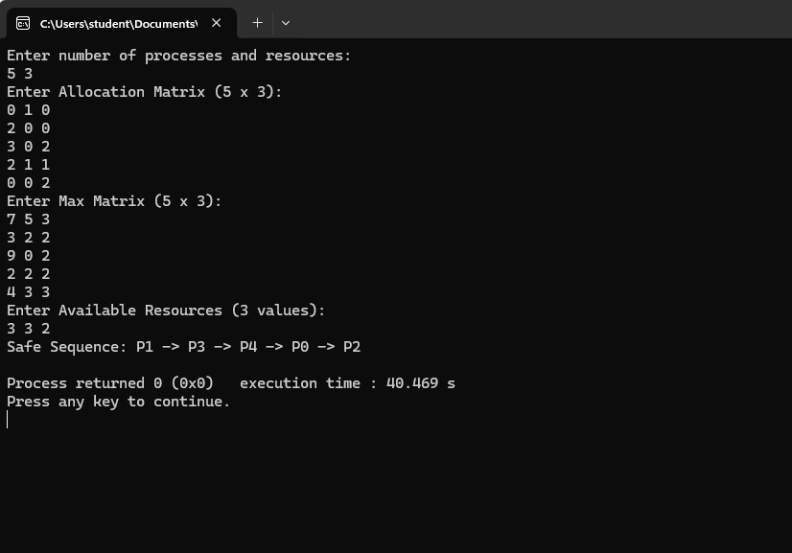

Observation:

